|  |  |  |  |  |  |
| --- | --- | --- | --- | --- | --- |
| Student Name | | Irina Gorozhina | Student Number | 473006578 | |
| Unit Code/s & Name/s | | ICTWEB519 Develop complex web page layouts  ICTWEB520 Develop complex cascading style sheets | | | |
| Cluster Name  *If applicable* | | Web Design Cluster | | | |
| Assessment Type | | Case Study  Assignment  Project  Other *(specify)* | | | |
| Assessment Name | | Five Page Website Project | Assessment Task No. | | 3 of 3 |
| Assessment Due Date | |  | Date Submitted | / / | |
| Assessor Name | | Vladimir Roudakov | | | |
| **Student Declaration:** I declare that this assessment is my own work. Any ideas and comments made by other people have been acknowledged as references. I understand that if this statement is found to be false, it will be regarded as misconduct and will be subject to disciplinary action as outlined in the TAFE Queensland Student Rules. I understand that by emailing or submitting this assessment electronically, I agree to this Declaration in lieu of a written signature. | | | | | |
| Student Signature |  | | Date | / / | |
| **PRIVACY DISCLAIMER:** TAFE Queensland is collecting your personal information for assessment purposes. The information will only be accessed by authorised employees of TAFE Queensland. Some of this information may be given to the Australian Skills Quality Authority (ASQA) or its successor and/or TAFE Queensland for audit and/or reporting purposes. Your information will not be given to any other person or agency unless you have given us written permission or we are required by law. | | | | | |

|  |  |
| --- | --- |
| Instructions to Student | **General Instructions:**  You are an employee of Uptown IT and you work in the Commercial Creative Department. Your role is to design and develop websites. Your manager has assigned you to a new project and you have received documentation regarding the project requirements and have attended two client meetings.  Your teacher/assessor will take on the role of a manager for Uptown IT Commercial Creative Department.  Read and familiarise yourself with the Project Scenario or Case Study before proceeding with project tasks. Confirm anything you are not sure about the project with your teacher. It is essential that you have a clear understanding of the scenario and tasks that you need to complete.  This assessment instrument requires the student to complete a project that is divided into four (4) parts:   * PART 1 Five (5) Page Website Project requirements * Task 1 Identifying the HTML requirements * Task 2 Creating the site structure and HTML layout * Task 3 Page layout design considerations * Task 4 Create HTML page layout sections * PART 2 Creating the external CSS file to format the site layout and appearance * PART 3 Test, debug and validate HTML and CSS against the W3C, WCAG and Autoprefixer   **Materials Required:**   * Students are required to provide their own storage device. The recommendation for this qualification is an external SSD drive with at least 500 GB capacity, if you need to store a copy of the Virtual Machine (VM). For assessment files only, a 64 GB thumb drive will be sufficient. * Access to computers. PCs and peripherals – these may differ between classrooms * Internet access * Access to a number of browsers * Access to different devices to test website * Access to Connect (LMS) * Word processing software, such as Microsoft Word. * Special purpose tools, equipment and materials to complete the assessment   **Online Delivery:**  Student to supply their own PC or laptop an Internet Access  **Documentation:**  Uptown IT Scenario or Case Study  Style Guide  **Assessment Criteria:**  To achieve a satisfactory result, your assessor will be looking for your ability to demonstrate the following key skills/tasks/knowledge to an acceptable industry standard. Demonstrated ability to:   * Identify legislative and organisational standards and procedures in relation to webpage development * Design a web page as per client specifications including a web form. * Create HTML and CSS layout structure * Use external CSS file * Use complex CSS to formal page layout * Flexible layout using Flexbox and/or Grid layout * Positioning page elements using complex CSS to suit site layout * Test design and functionality of a web page against W3C * Test and debug a web page * Test is at least two (2) browsers and two (2) devices * Vendor prefixes tested using Autoprefixer or similar tool * Web accessibility in compliance with WCAG 2.1 AA * Obtained client sign off * Six (6) knowledge questions related to WCAG, browser incompatibility, web libraries and web frameworks   **Refer to the marking criteria for specific details:**  ICTWEB519_520_AT3_MC_TQM_v1  **Details of location:**  Skills and knowledge in this competency unit must be demonstrated in a workplace or simulated environment where the conditions are typical of those in a working environment in this industry.  Research and project activities may be conducted in the classroom or at home.  If you are unable to attend a scheduled assessment activity, you must notify your teacher before the assessment is due and supply a doctor's certificate and approval from the team manager for an extension.  **Time Restrictions:**  This assignment is designed to take place over 5 weeks or approximately 20 hours. The student is expected to attend classes as per timetable details and should be able to commit up to 3 hours per week of their own time to study or study related activities.  **Interactions:**  Teamwork skills are essential in the IT industry therefore you should work in teams to consult and collaborate on practical activities. However, each student must complete the assessment tasks individually (unless indicated).  **Level of Assistance Permitted:**  Staff cannot directly show students answers or solutions but support and guide them to complete tasks individually. Teachers and tutors should be available in class, and accessible by email for students working from home.  **Contingencies:**  A reasonable adjustment is available to students for a variety of reasons, including disability, language, literacy, and numeracy (LLN) problems or extenuating circumstances.  **Work, Health and Safety:**  The work environment should be assessed for safety prior to class. Special consideration should be taken regarding potential ICT related hazards such as tripping hazards, electromagnetic radiation, ergonomics, and posture. TAFE Queensland health and safety policies and procedures should be followed at all times.  **Number of Attempts:**  You will receive up to two (2) attempts at this assessment task. Should your 1st attempt be unsatisfactory (U), your teacher will provide feedback and discuss the relevant sections / questions with you and will arrange a due date for the submission of your 2nd attempt. If your 2nd submission is unsatisfactory (U), or you fail to submit a 2nd attempt, you will receive an overall unsatisfactory result for this assessment task. Only one re-assessment attempt may be granted for each assessment task.  ***For more information, refer to the Student Rules.*** |
| Submission details | **Evidence Required to be Submitted:**  Insert your details on page 1 and sign the Student Declaration. Include this template with your submission.  **Deliverables:**  For this assessment item you need to complete the written sections in this document, then rename it to:   * AT3_Written_Surname_Student Number   Complete the website project and rename the site folder as:   * AT3_Website_Surname_Student Number   Create a folder:   * ICTWEB519_520_AT3_Project_Surname_Student Number   Insert the two files you renamed above into this folder, compress it (e.g. with WinZip) and upload it via Connect.  **Submission via Connect:**  Upload a single file into Assessment 3 (AT3) Assignment Folder in Connect  Multiple files can be compressed into a single file  Name the file:  ICTWEB519_520_AT3_Project_Surname_Student Number  TAFE Queensland Learning Management System:  **Accessing Connect:**  Connect URL: <https://connect.tafeqld.edu.au/d2l/login>  Username: 9 digit student number  Password: <your password>  For password reset go to: <https://passwordreset.tafeqld.edu.au/default.aspx> |

|  |  |
| --- | --- |
| Instructions for the Assessor | **Online Delivery:**  Please revise and modify the Instructions to Student section if you are delivering online.  **Specifications of Assessment:**  To be judged competent in this assessment item the student is required to demonstrate competence in all indicators shown in the marking guide.  Gather evidence to demonstrate consistent performance in conditions that are safe and replicate the workplace. Noise levels, production flow, interruptions and time variances must be typical of those experienced in the web development field of work and include access to:  web development environment  project requirements  Ensure that students read and familiarise themselves with the Project Scenario and the Client provided relevant files and/or resources before attempting the assessment.  **Storage Devices:**  Students are required to provide their own storage device. The recommendation for this qualification is an external SSD drive with at least 500 GB capacity, if you need to store a copy of the Virtual Machine (VM). For assessment files only, a 64 GB thumb drive will be sufficient.  **Assessor to Provide Access to:**   * Access to lab computers. PCs and peripherals - these may differ between classrooms * Internet access * Access to a number of browsers * Access to different devices to test website * Access to Connect (LMS) * Word processing software, such as Microsoft Word. * Special purpose tools, equipment and materials to complete the assessment   **Online Delivery:**  Student to supply their own PC or laptop an Internet Access  **Documentation:**  Uptown IT Scenario or Case Study  Style Guide  **Level of Assistance Permitted:**  Teachers and tutors should be available in class, and accessible by email for students working from home. Staff cannot directly show students answers but guide them to where to go to complete tasks individually. Students with disability will receive reasonable adjustments.  **Interactions:**  Teamwork skills are essential in the IT industry therefore you should work in teams to consult and collaborate on practical activities. However, each student must complete the assessment tasks individually (unless indicated).  **Contingencies:**  A reasonable adjustment is available to students for a variety of reasons, including disability, language, literacy, and numeracy (LLN) problems or extenuating circumstances.  **Work, Health and Safety:**  The work environment should be assessed for safety prior to class. Special consideration should be taken regarding potential ICT related hazards such as tripping hazards, electromagnetic radiation, ergonomics, and posture. TAFE Queensland health and safety policies and procedures should be followed at all times.  **Assessment Conditions:**  Skills and knowledge in this competency unit must be demonstrated in a workplace or simulated environment where the conditions are typical of those in a working environment in this industry. |
| Note to Student | An overview of all Assessment Tasks relevant to this unit is located in the Unit Study Guide. |

## Case Studio - Scenario

**CLIENT DETAILS:** **ML Strength - Health and Fitness**

We train athletes – professional, collegiate, youth, and anybody that wants to train like an athlete. When we speak of training we are talking about speed, strength, power, and sports therapy.

Our business is aimed at a health conscience adult who wants to move beyond the usual local gym.

**About us**

We are a Brisbane based company with clubs at Ashgrove, Brisbane City, Chermside, Graceville and Westlake.

ML Strength are Australia's newest brand in health and fitness, with gyms opening throughout the Brisbane metropolitan area. ML Strength believes fitness comes first and keeping fit and improving your health is not just a fad - it's a way of life. Whether your goal is weight loss, body building, nutrition or diet improvements, having more energy, or just looking and feeling better - we're here for you!

ML Strength can offer cutting edge exercise options, including group fitness classes and one-on-one personal training sessions for weight loss, circuit training, boxing and karate. Our trainers are all Les Mills accredited instructors and are second to none – all have Bachelor Degrees in Human Movements.

We are a family operated business that has little to do with the rest of the fitness industry. Our gym world does not include the annoying telemarketers or membership consultants. Our gyms speak for themselves, our members do our marketing. We believe that word of mouth has way more credibility than something that a marketing machine dreams up.  You are always welcome to look through any of our gyms at your own pace, with no pressure whatsoever. With hard-selling 'health club' sales consultants hustling you on every corner, we pride ourselves on being a refreshing change from that. Our 'no obligation, no pressure' attitude is clearly evident with our $10 CASUAL visit rate.

We have created gyms that we would love to train in and share that passion and enthusiasm with our valued members. Our gyms have an old school feel with a new school attitude!

We are open 24:7. YOU can now train any time you like, weekdays, weekends & public holidays. WE ARE OPEN! Unlike other so called 24:7 gyms, we are staffed all the time. If you need a late night workout, a protein bar or shake, supplements or a cool t-shirt, we are open for you. Our class times change constantly so check out on the web site for the timetable at each of our clubs.

The range of group fitness classes provided by ML Strength is listed below.

Body attack

Zumba

Body pump

Body step

Rpm

Body balance

Body combat

Body jam

Body vive

Cycle

Cycle extreme

Pilates

Yoga

Aqua fit & aqua mode

Boxing & TAE box

Step moves, step basic & step burner

Rejuvenate, low impact & gentle fitness

Cardio blitz & cardio circuit

World dance & dance

Hilo & fat burner

Sculpt & combo

Power hour

ABT

Abs blast

Tai chi

Chi ball

**About the owner and his philosophy**

Hi, my name is Maurice Lidman and my background is in boxing. I competed as an amateur in my early years and now like to share my knowledge and expertise as a coach. It is not unknown for me to jump into the ring as your sparring partner.

For over three decades Maurice has been involved in the boxing scene. He has competed as an amateur in his early years and now shares his knowledge and expertise as a coach, by running his boxing classes with passion and enthusiasm.  
  
The atmosphere in our boxing classes is fun, exciting and highly energised.  
  
Whether it is your first class or you're an intermediate level boxer, you will gain a lot by becoming involved. It is one of the best cardiovascular workouts available.

## PART 1 - Five (5) Page Website Project requirements

You are an employee of Uptown IT and you work with the Commercial Creative Department. Your role is to design and develop websites. Your manager has assigned you to a new project and you have received documentation regarding the client’s requirements and attended two project meetings. The client wants a website to advertise the services they provide and entice people to visit the health and fitness centre.

**Task 1. Identifying the HTML requirements**

Your task is to create a five (5) page website for the scenario presented. Read the scenario and identify the content that you plan to include into each page. The client wants to keep the pages to a minimum so there would be no additional pages created at this stage of the project.

Traditional web pages tend to have individual pages, one per file, with a set of common dependencies. These dependencies may include an external CSS file and some scripting code such as JavaScript. If necessary, to format the position or appearance of a specific element you can use inline CSS. This project mainly involves working HTML and CSS but some scripting may be included to enhance the user experience if desired.

The site must be responsive to different screen sizes. Sample wireframes have been included to guide you through the page layout and implementation on at least two devices (screen and phone). Duplication of header, footer and navigation is discouraged, find a way to overcome this problem and generate common sections from a single instance.

Before proceeding to design the page ensure that you understand the message that the client intends to convey to their potential customers with the page’s content and layout.

For sections 1.1 to 1.3, write a response below each question. Provide details answers.

1.1 What does the client want to achieve with this web page?

The client, ML Strength - Health and Fitness, wants to achieve the following goals with their web page:

* ***Advertise Services:*** The primary goal of the website is to effectively advertise the various health and fitness services they offer.
* ***Attract Visitors:*** The website should entice people to visit their health and fitness centres in Brisbane. They want to attract new members to join their gyms.
* ***Showcase Expertise:*** ML Strength emphasizes the qualifications of their trainers all accredited instructors with Bachelor Degrees in Human Movements.
* ***Promote 24/7 Access:*** The client wants to communicate that their gyms are open 24/7, distinguishing them from other gyms that might not be staffed around the clock.
* ***Provide Class Information***: They aim to list the various group fitness classes they offer, which is a key aspect of their services.
* ***Introduce the Owner: The*** website should introduce the owner, Maurice Lidman, and emphasize his background and experience in boxing.
* ***Show an Energetic Atmosphere:*** The client wants the website to convey the energetic and fun atmosphere of their classes.

1.2 Who is the target audience for the page?

The target audience of the ML Strength – Health and Fitness web page includes the following groups:

***Adults who care about their health:*** this is the main target audience. ML Strength's goal is to attract health-conscious adults who are looking for a fitness facility that goes beyond the traditional local gym. These people are interested in improving their health and maintaining physical fitness. They can be of different ages, including young adults and middle-aged people.

***Fitness enthusiasts:*** This includes people who are passionate about fitness, bodybuilding and exercise. They may be interested in the various fitness activities and training programs offered by ML Strength.

***Boxing enthusiasts:*** people interested in boxing and related fitness activities. Maurice Lidman, the owner, has a background in boxing and offers boxing lessons. These classes are designed to attract boxing fans of all skill levels.

**Brisbane Locals:** With ML Strength having several clubs in the Brisbane metropolitan area, locals looking for fitness options are part of the target audience.

People who require 24/7 access: ML Strength provides 24/7 access to its gyms, so the target group is people who prefer a flexible training schedule, including late night workouts or workouts on weekends and holidays.

***Individuals interested in group fitness classes:*** ML Strength offers a wide variety of group fitness classes. The target audience includes people interested in classes such as Body Pump, Zumba, Yoga, etc.

1.3 Are there any legislative or organisational standards that the designer/developer must comply with in the development of the web page?

Research legal obligations for online business and complete the table below. A good starting point is visiting [Business Queensland](https://www.business.qld.gov.au/starting-business/internet-start-ups/online-basics/legal-obligations)[1]

|  |  |  |
| --- | --- | --- |
| LEGAL OBLIGATION | ACTIONS REQUIRED | SOURCE |
| Privacy Laws | Implement a clear and accessible privacy policy on the website, otlining how user data is collected, used, and stored. Obtain explicit consent from users for data collection and processing. Ensure secure storage and transmission of personal information. | Privacy Act 1988  [Privacy Act 1988](https://www.oaic.gov.au/privacy/the-privacy-act/) |
| Copyright and Intellectual Property | Obtain permission or licenses for any copyrighted material, images, or content used on the website. Clearly state the copyright owner and usage terms for original content. | Copyright Act 1968  [Copyright Act 1968](https://www.legislation.gov.au/Details/C2022C00192) |
| Consumer Protection Laws | Clearly display the terms and conditions of sale on the website, including refund and return policies. Provide accurate product descriptions and pricing information. | Australian Consumer Law (Competition and Consumer Act 2010)  <https://www.legislation.gov.au/Details/C2011C00003> |

**Task 2 Prepare site environment: folder structure, naming convention**

1.4 Create an appropriate folder structure. All folders must contain relevant files and each folder should not exceed 1 MB.

1.5 The index.html file must be placed in the root folder

1.6 Naming convention: All filenames must be descriptive of the content, lowercase, and no spaces are allowed in the names of files and objects as specified in the style guide.

**Task 3 Responsive page layout design considerations**

1.7 The page layout design must conform to these requirements:

1. A responsive five (5) page website (to suit multiple devices
2. A hamburger menu that is responsive
3. Animated: hover state for menu items
4. Format and appearance as per style guide
5. Web Form:

A minimum of seven form fields

Four different input types

Attributes with input restrictions: pattern, maxlength, max, min and title for error message

Every input field needs a label and error div

Element(s) for errors in form input empty by default

A ‘help’ function (link)

Use of a scripting language to add interactivity is allowed but not mandatory

1.8 Create a wireframe or skeletal outline of the page layout, that is, a diagram or sketch that identifies each section of the page, with elements positioning and dimensions. Name all sections in the layout diagram. It is expected that the 5 pages will have a common basic layout but small differences are allowed for example, for the web form page. Create a separate wireframe diagram any page that partially modifies the layout.

These diagrams will be used as the blueprint to create the HTML pages.

You need two versions of the page layouts (wireframes) to suit the layout of at least two (2) devices, for example a PC/laptop screen and a mobile phone screen.

19. Access the style guide provided and document the typography, iconography and colour scheme for each elements/section outlined in the wireframe diagram.

|  |  |  |  |
| --- | --- | --- | --- |
| Site Section/Page | Typography | Iconograph/Images | Colour Scheme |
| *Header and navigation* | Logo:80px  Subtitle: 40px,  Menu Link: 16px,  Buttons: 20px | Logo Image | Header: # #274c77  (dark blue)  Buttons colour: #a3cef1 (light blue)  Font: "Arial", "Veranda", sans-serif |
| Home | Title: 60px,  Subtitle: 40px,  Content: 26px | Sport people Images | Background: Image  Header: # #274c77  (dark blue)  Font: "Arial", "Veranda", sans-serif  Font colour: white |
| About Us: | Title: 60px,  Subtitle: 40px,  Content: 26px  Buttons: 20px | Own’s Image  Gym’s Image | Background Colour: none  Header: # #274c77  (dark blue)  Buttons colour: #274c77, #54abf1  (Dark blue and blue)  Font: "Arial", "Veranda", sans-serif  Font colour: black |
| Classes | Title: 60px,  Subtitle: 40px,  Content: 26px  Buttons: 20px | Video | Background Colour: image  Header: #a3cef1 (light blue)  Buttons colour: #274c77, #54abf1  (Dark blue and blue)  Font: "Arial", "Veranda", sans-serif  Font colour: White |
| Membership | Title: 60px,  Subtitle: 40px,  Content: 26px  Buttons: 20px | Membership Image | Background Colour: none  Header: # #274c77  (dark blue)  Buttons colour: #274c77, #54abf1  (Dark blue and blue)  Font: "Arial", "Veranda", sans-serif  Font colour: black |
| Contact section | Title: 40px,  Content: 24px, Links: 24px |  | Background colour: #54abf1  Header: # #274c77  (dark blue)  Buttons colour: #274c77, #54abf1  (Dark blue and blue)  Font: "Arial", "Veranda", sans-serif  Font colour: black |
| Footer section | Links: 16px | Icons: Facebook, Instagram | Background colour:  # #274c77 (dark blue)  Lincs fount colour: white  social-icons font colour: black  Font: "Arial", "Veranda", sans-serif |

**Task 4 Create HTML 5 page layout sections**

1.10 HTML 5 has been selected as the most appropriate markup language for the task. Create the pages as per wireframe structures and making sure that you:

1. Use semantic elements only for the layout structure
2. Use ID and CLASS elements as required when no semantic element exists for the function
3. Create the menu with HREF elements that target the required sections
4. Ensure that content is delivered one screen at a time with internally targeted hyperlinks
5. Correct indentation of HTML code

## PART 2 - Creating the external CSS file to format the site layout and appearance

2.1 Create an external CSS file and save it in the CSS folder. This file will provide the common formatting features for the five (5) pages.

2.2 Create the necessary CSS rules to produce the required format and appearance:

1. Flex and/or Grid model and @media queries to achieve responsiveness
2. Layout should be in flow. No position: absolute (position: fixed mobile view allowed)
3. Layout style on user-defined classes
4. Common CSS for site pages – external CSS
5. One common menu using list items li elements (delivered via CSS or code)
6. One common footer (delivered via CSS or code)
7. Demonstrated use of two types of CSS combinator and three pseudo-classes
8. Text styles consistently applied for headings, paragraph, and figcaption as per style guide
9. Form CSS:

* Use grid layout and @media query to remove input not required
* Use @media query rules to remove labels in mobile view and set width 100%
* Use four form-specific pseudo-classes to aide in user input functionality
* Use ::before or ::after pseudo-element to denote fields with required attribute
* Overlay an absolute or fixed position video element on hover of the ‘help’ link
* Ensure the user is aware of erroneous input as they are inputting text into your form
* Use an absolutely positioned icon inside each relatively positioned tex t::after

Ensure that the layout is consistent with the wireframes prepared/refined in Task 3 -1.8.

PART 3 - Test, debug and validate web page

3.1 Test the webpage design and functionality to confirm that it has been developed according to the client’s requirements and the layout design.

|  |  |
| --- | --- |
| Site section /Page | Testing practice |
| *Navigation and burger menu* | Navigation buttons work correctly. The company logo is clearly visible on a blue background. Burger menu works correctly. |
| Home page | The text is easy to read, and pictures emphasize the meaning of what is read and |
| *About Us* | The text is easy to read, and pictures emphasize the meaning of what is read bottom is clearly visible. |
| *Classes* | The class categories are clearly separated. The link with the video is working correctly.Now buttons are clearly visible |
| *Membership* | Form fields: max length, max, min and title for error message are working correctly. |
| *Contacts* | The form fields: max length, max, min and error message title work correctly. The “Help” button also works correctly and goes to the link. |

3.2 Use browser developer tools to debug page design and functionality as required until it meets the client’s requirements. Check with your manager (teacher/assessor) to confirm requirements, as required.

|  |  |
| --- | --- |
| Design or Functional Requirement | Screenshots |
| *The background image is very large. The pictures of the coaches are not horizontal. The font is too small.. Searched for a solution on W3C.* |  |
|  |  |
| The sandwich menu is not fixed. The mobile version has the wrong dimensions.  I was looking for a solution at W3C. |  |
|  |  |

3.3 For each page, validate HTML and CSS using the W3C Markup Validation Service. Provide screenshots.

|  |  |
| --- | --- |
| **Page** | **Before** |
| Index.html |  |
|  | **After** |
| Index.html |  |
| **Page** | **Before** |
| About us.html |  |
|  | **After** |
| About us.html |  |
| **Page** | **Before** |
| Classes.  html |  |
| **Page** | **Before** |
| Membership.html |  |
|  | **After** |
|  |  |
| **Page** | **Before** |
| Contact.html |  |
| Contact.html | **After** |
|  |  |
|  |  |
| **Page** | **Before** |
| Style.css |  |
|  | **After** |
|  |  |

3.4 Test cross-browser compatibility. The test includes at least two (2) browsers and two (2) devices. Fix as necessary. Re-test. Provide screenshots as evidence.

|  |  |
| --- | --- |
| **Chrome** Version 116.0.5845.188 | **Firefox** Version 117.0 |
|  |  |
|  |  |
|  |  |
|  |  |
|  |  |
|  |  |

3.5 Run Autoprefixer or similar tool to parse your CSS file and add vendor prefixes to your CSS. Fix as necessary. Re-test. Provide screenshots.

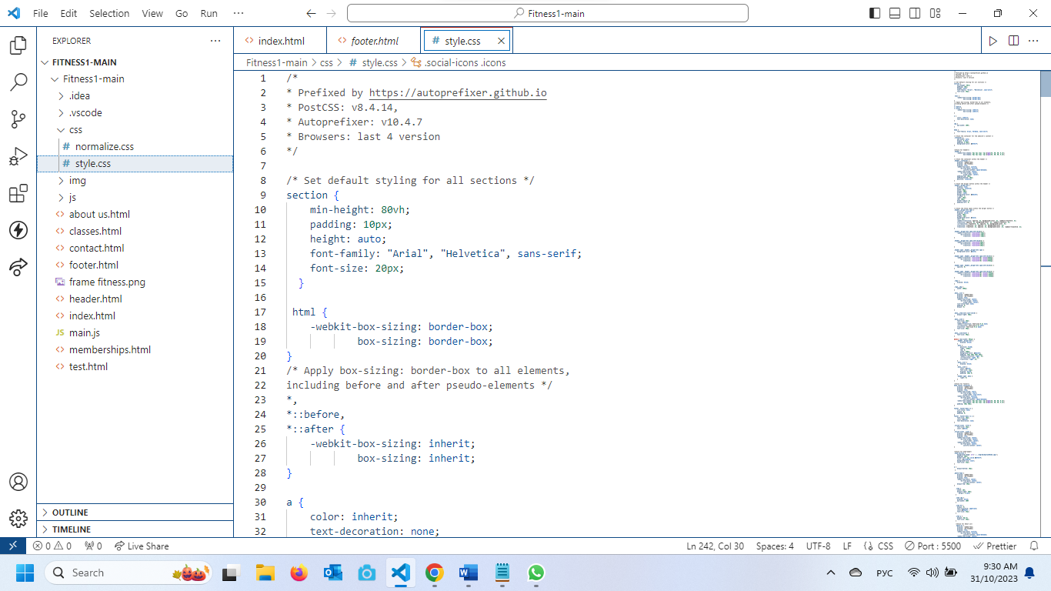

3.6 In order to confirm accessibility has been met at the required level, you can use Achecker or similar tool. The tool checks HTML elements (sections are also HTML elements) compliance with WCAG 2.1 on each page in the website. The tool outputs a comprehensive report that identifies errors, warnings and tips.

Your task is to run an accessibility checker tool on your completed website. Test for WCAG 2.1 Level-AA. Provide report or screenshot. However, if there are errors, fix them and provide a new report and screenshot. If some errors cannot be fixed, explain why this is the case. For example, it may require assistive technology that you don’t have access to. Once all errors are fixed you can add the WCAG 2.1 compliance logo to your website. 

**Home page:**

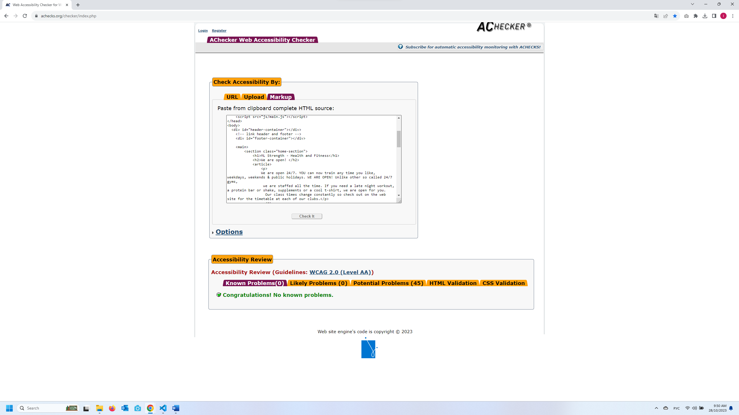

**Page About Us:**

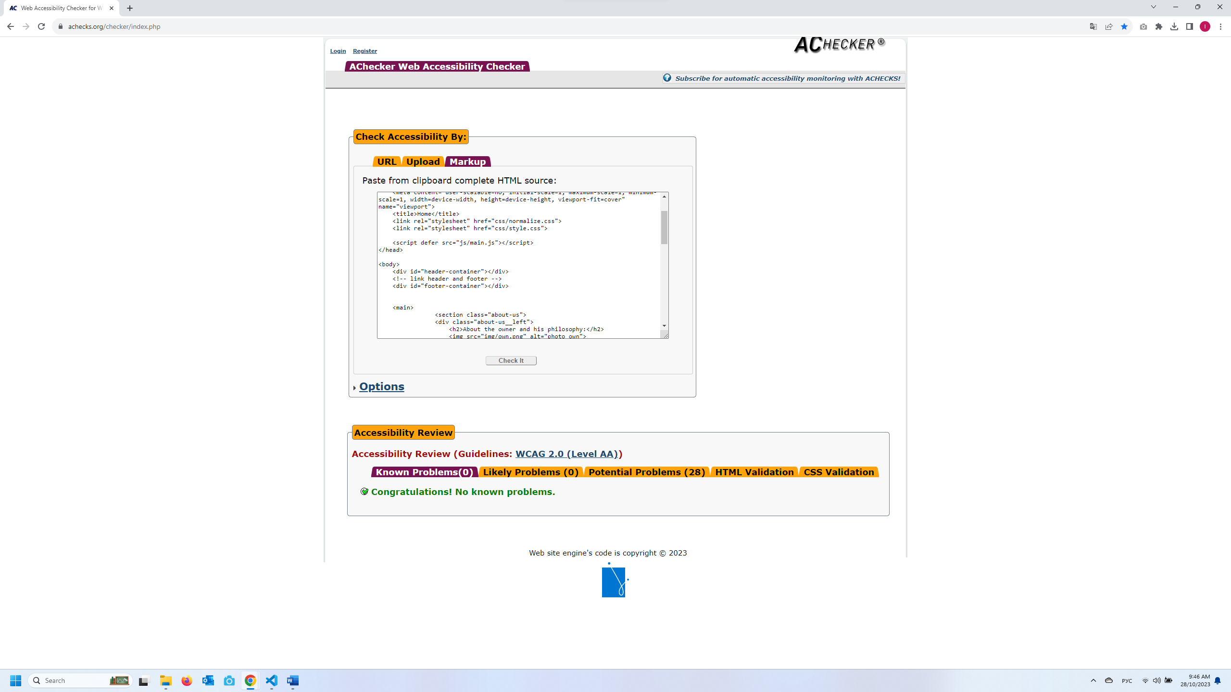

**Page Classes:**

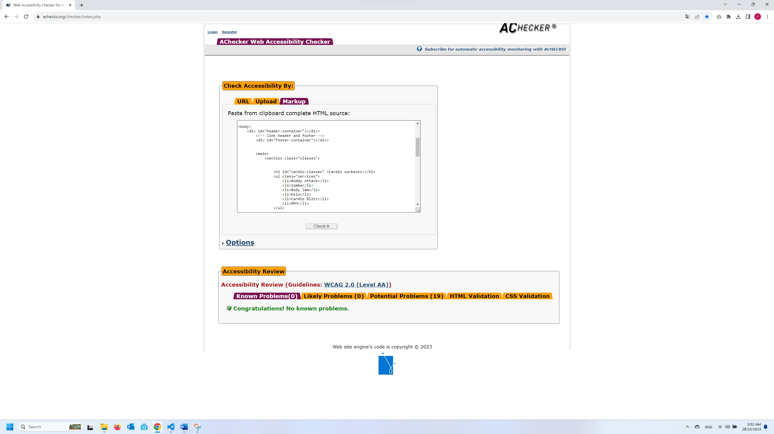

**Page Membership with mistakes:**

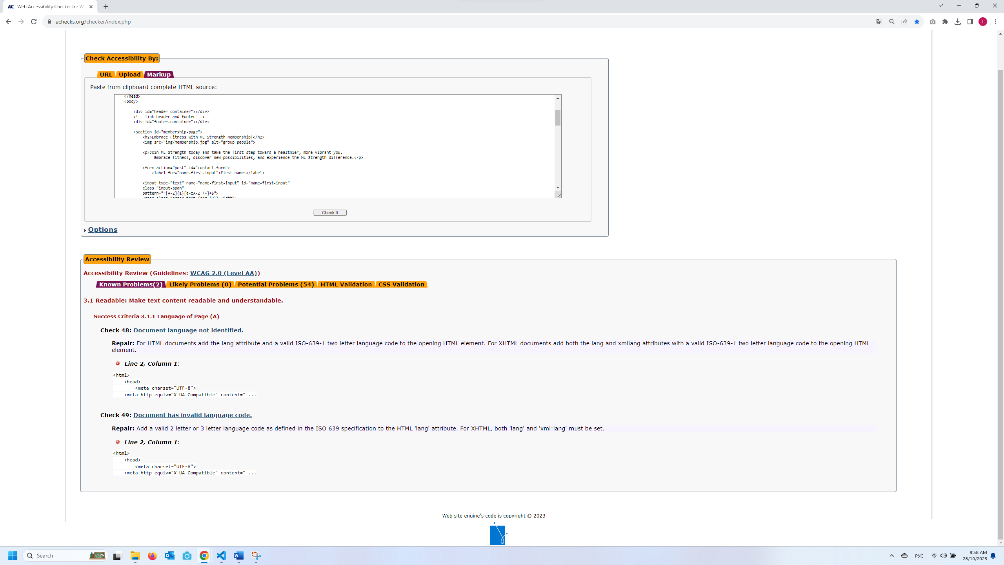

**After:**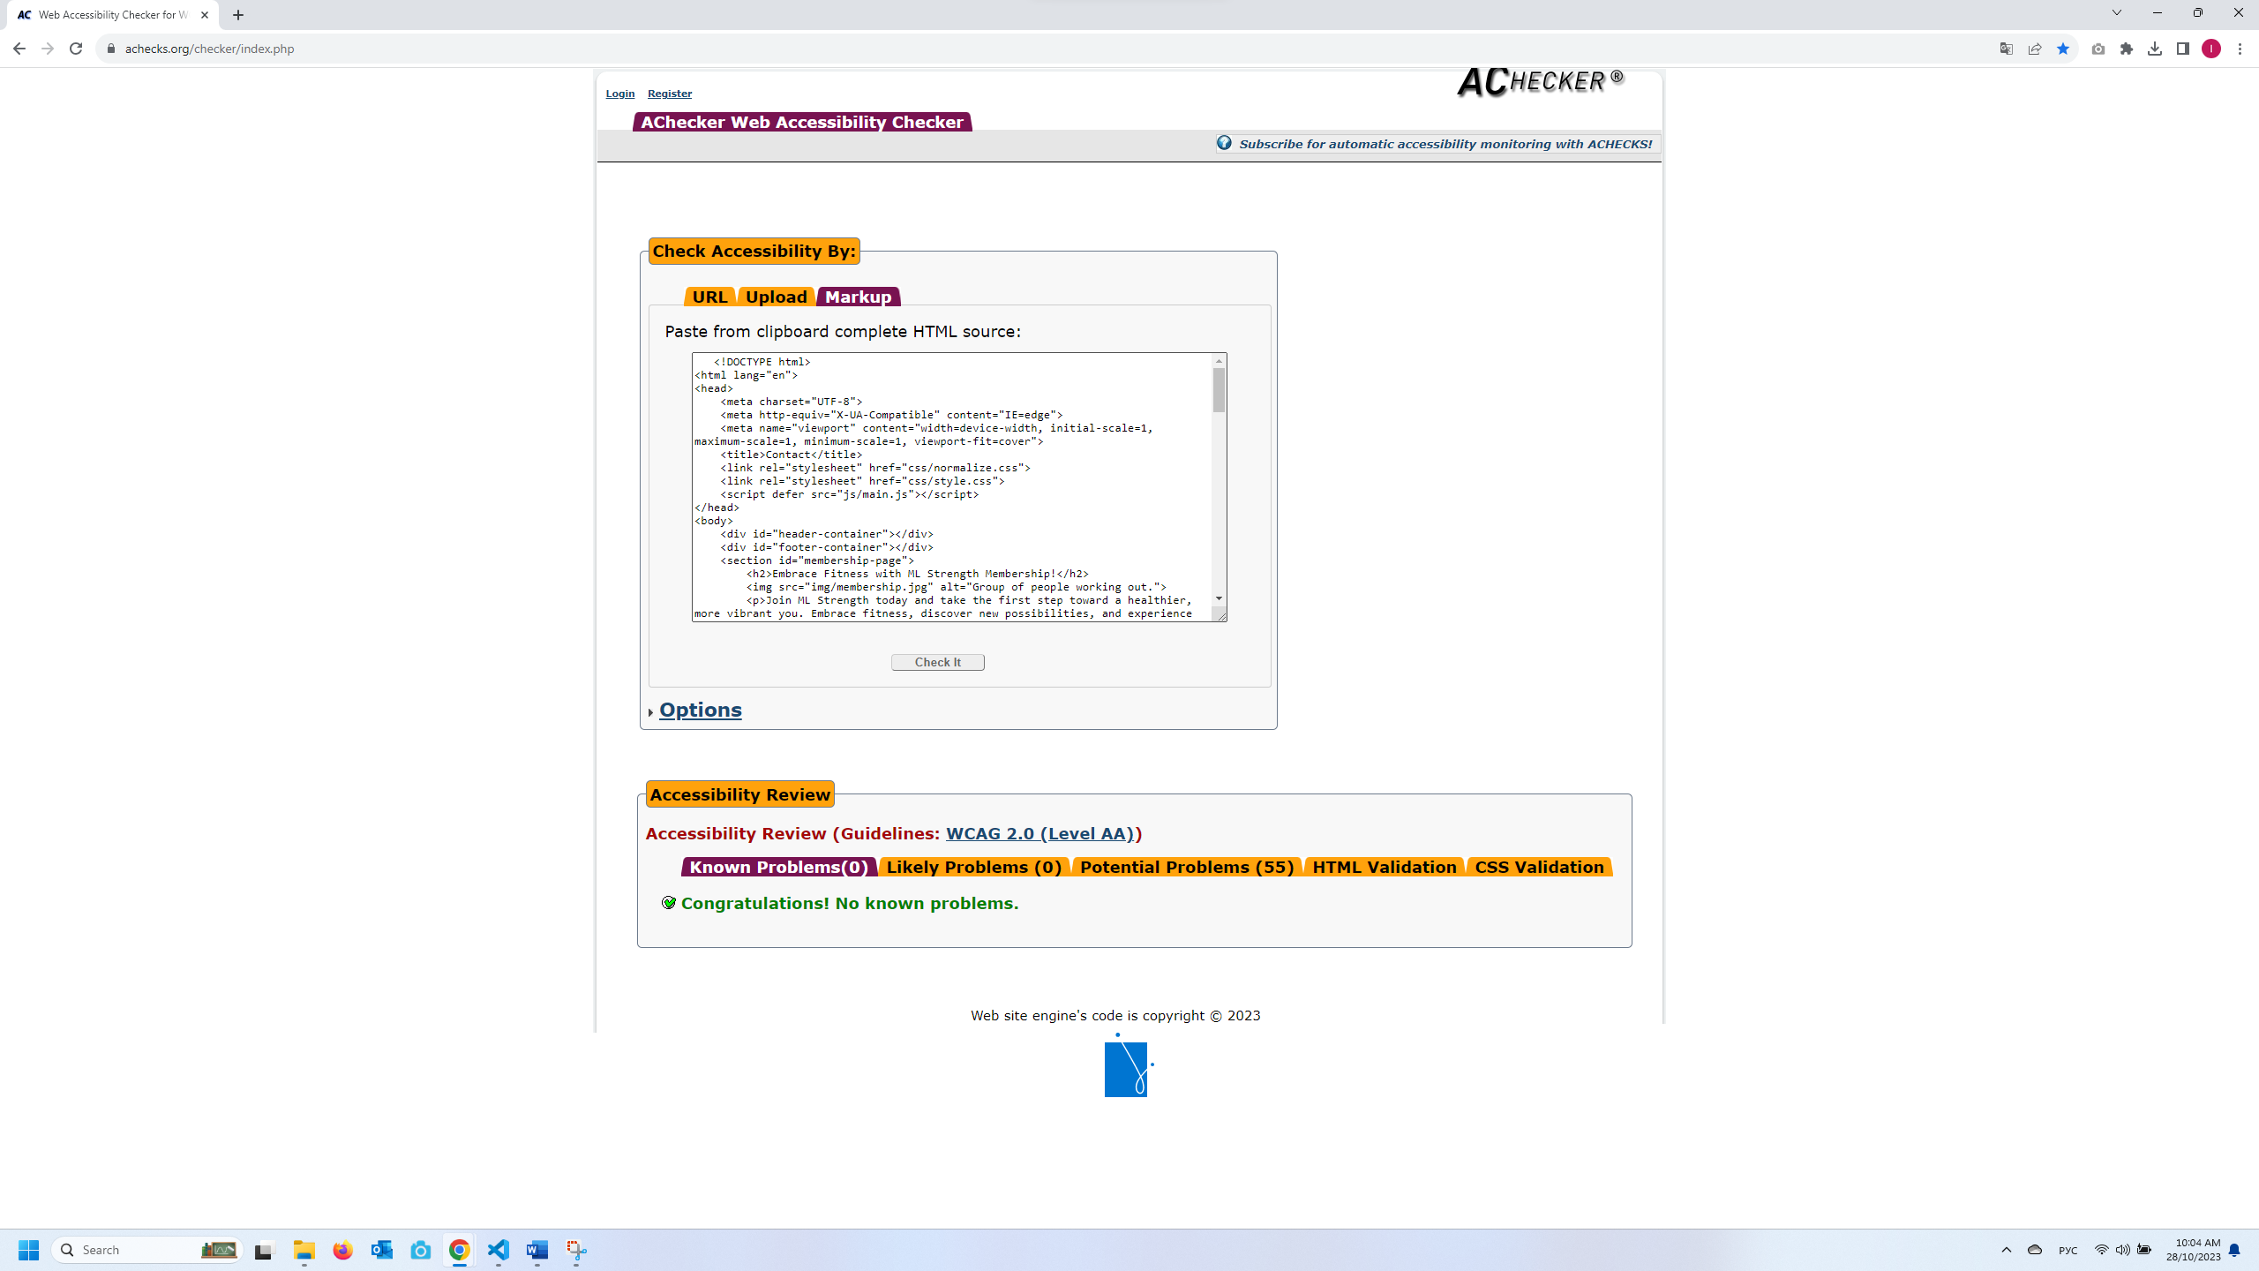

**Page contacts with mistakes:**

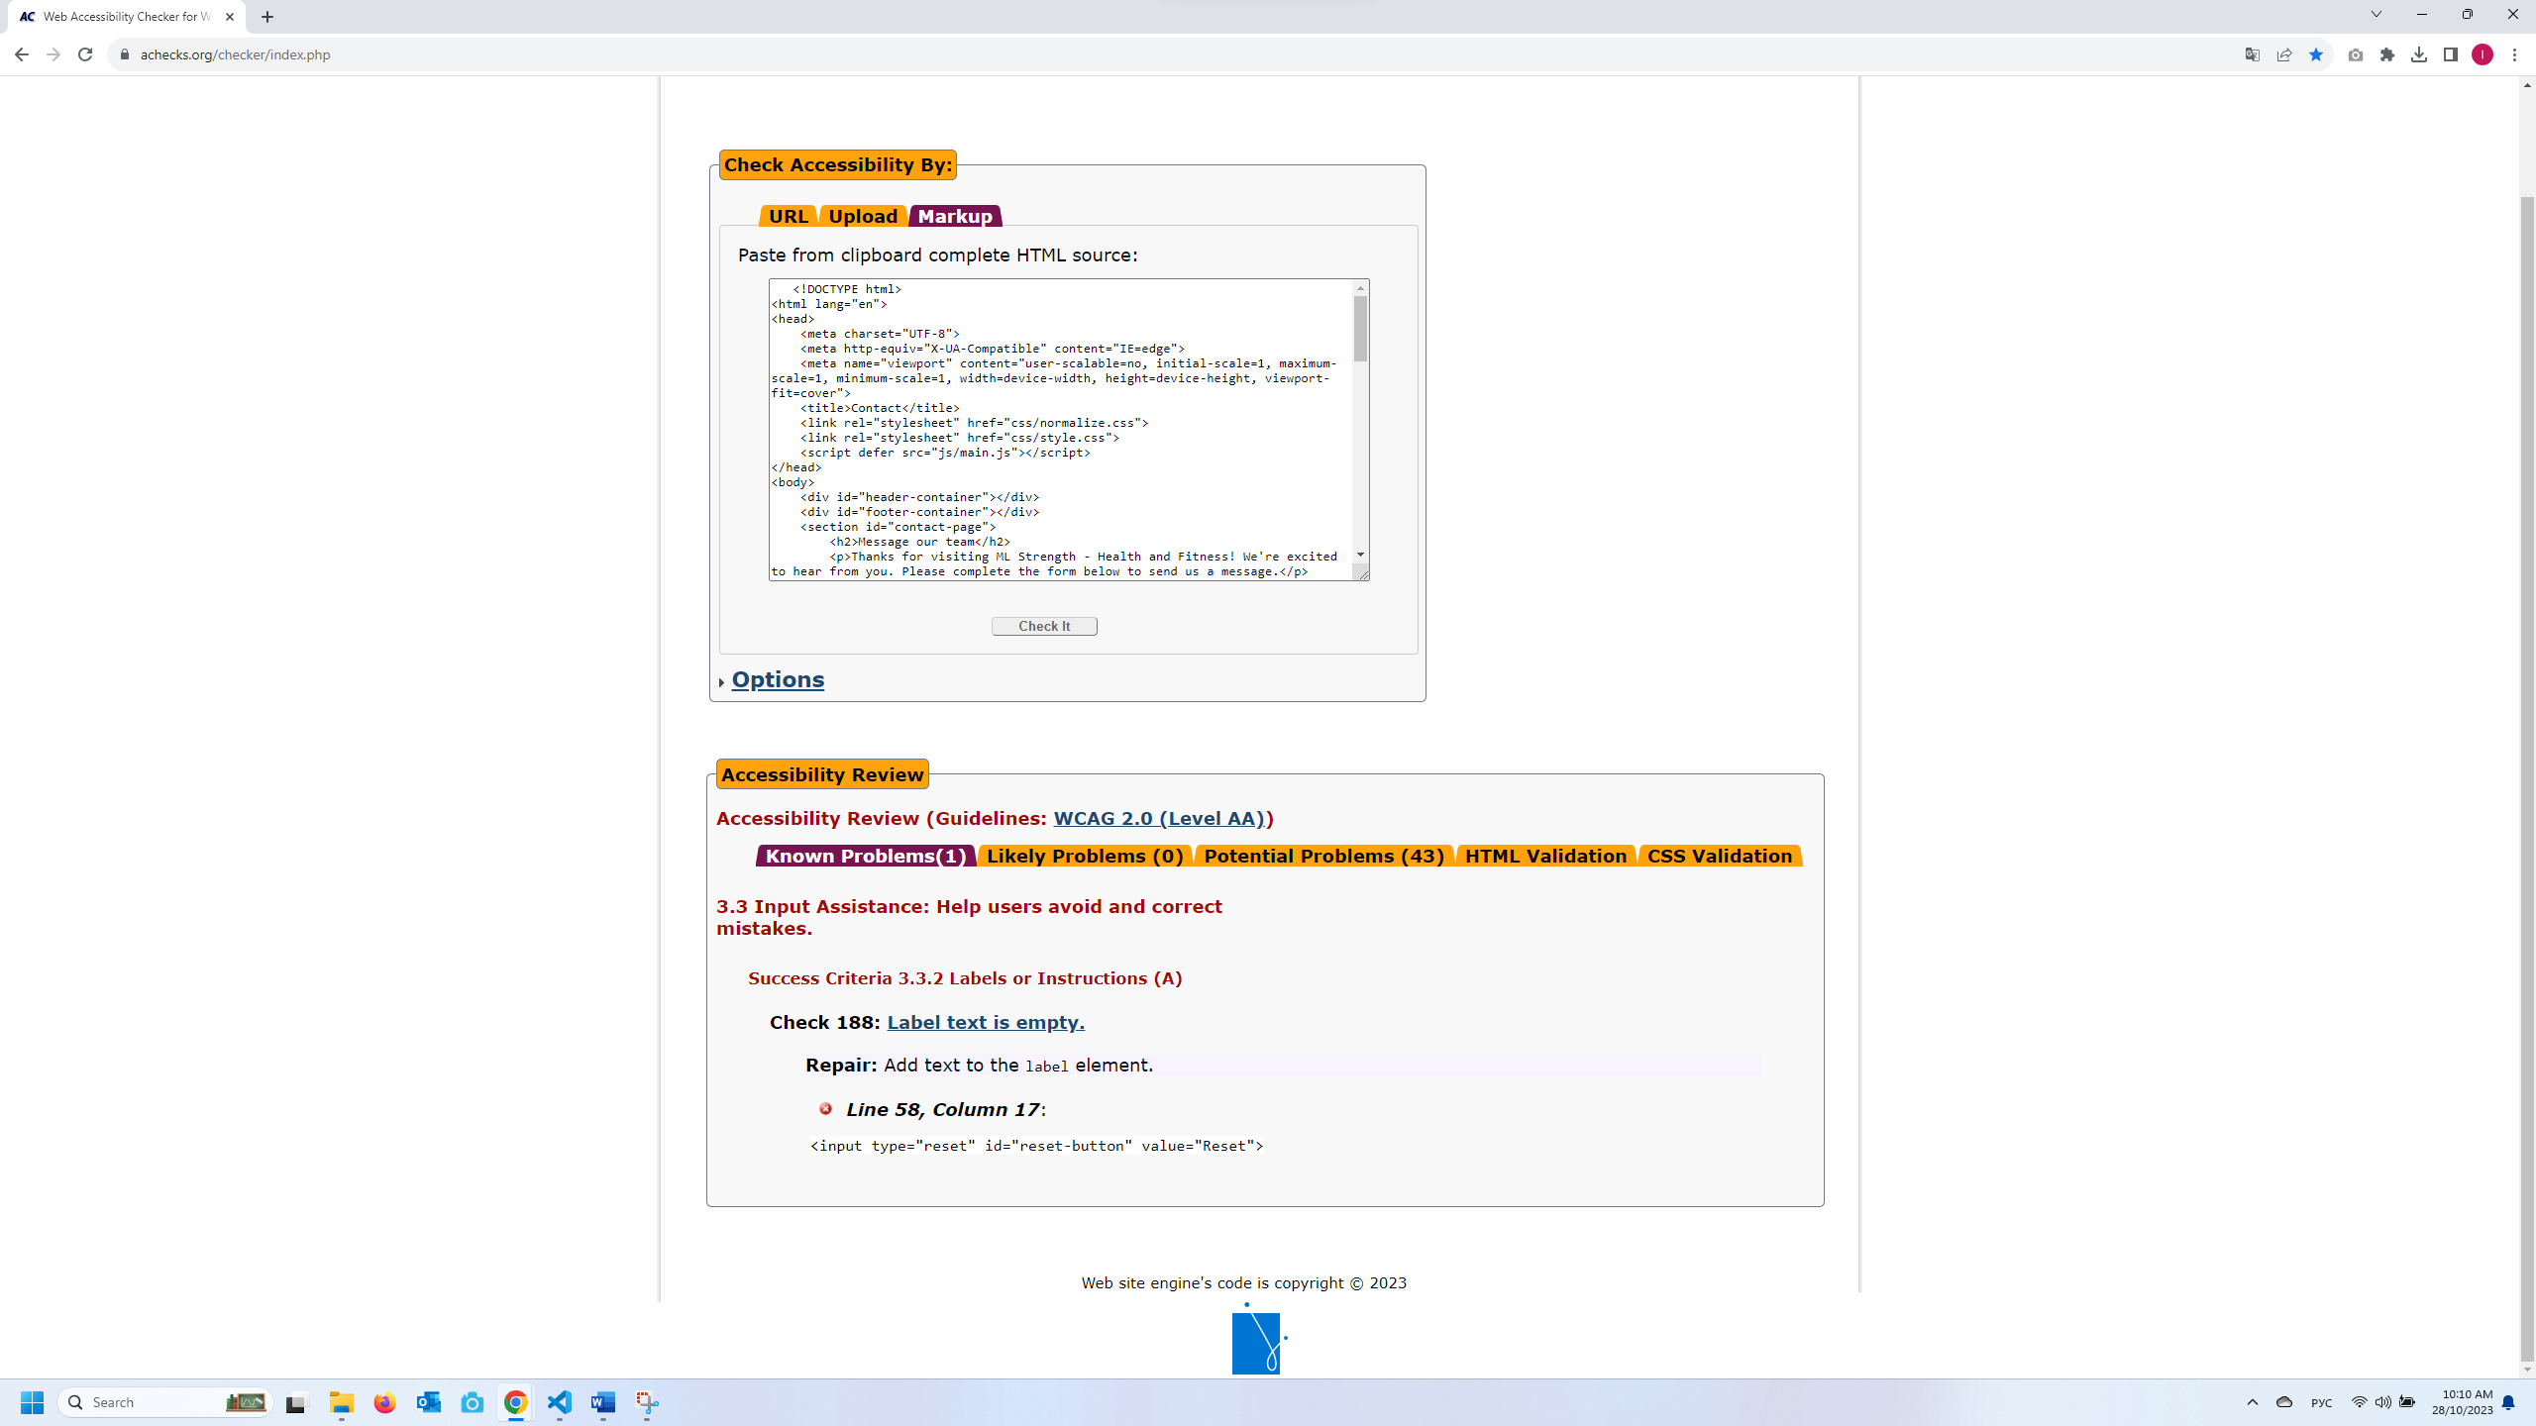

**After:**

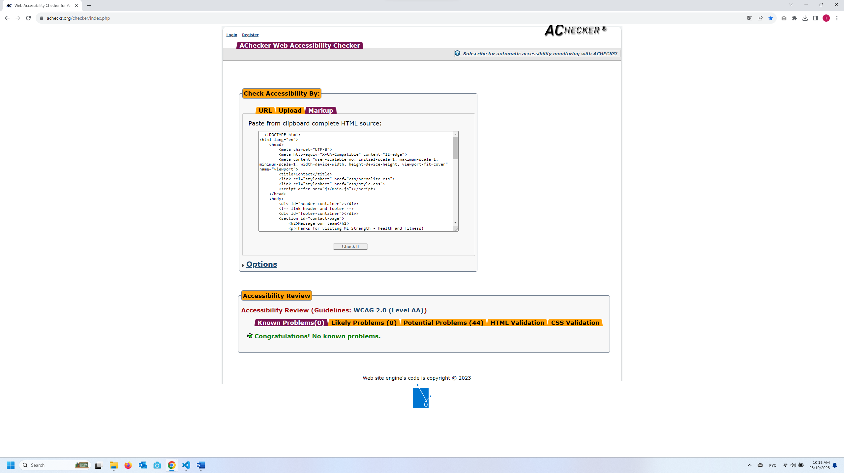

3.7 There are areas of concern in terms of cyber security for this project. Implement at least 1 cyber-security measure for each of the following areas:

* Authentication process

The login and password authentication process is a fundamental aspect of securing user access to online systems. When users attempt to log in, they provide a unique username or email along with a corresponding password. The system then verifies the provided credentials against stored user data.

* Programmatically engineered solutions to avoid cyber-attacks

Programmatically engineered solutions are vital for cyber defence, encompassing measures like firewalls, encryption, secure coding, access control, and intrusion detection. Regular updates, threat monitoring, and user training further bolster protection. These strategies collectively fortify systems against cyber threats and help maintain a secure digital environment.

* Protocols

Effective cyber security protocols establish guidelines for secure communication and data exchange. Examples include HTTPS for encrypted web connections, SSL/TLS for data encryption, and SSH for secure remote access. By adhering to these protocols, organizations ensure that data transmission remains confidential and protected from interception or manipulation by malicious actors.

3.8 Attend a meeting with your manager seeking confirmation of project completion.

Obtain sign off from the client representative.

|  |  |
| --- | --- |
| **PROJECT SIGNOFF**  Signing off on this document signifies that the client representative is satisfied with the completed project. The client acknowledges satisfaction and completion with all elements of the project. | |
| Client Representative Signature:    Date: 23/10/2023 | Developer Signature:  Date: |
| **PROJECT NOT APPROVED**  Please provide feedback below and attach any relevant information to assist the project team in making the changes needed. | |

**End of Assessment**

**DELIVERABLES:**

For this assessment item you need to complete the written sections in this document, then rename it to:

AT3_Written_Surname_Student Number

Complete the website project and rename the site folder as:

AT3_Website_Surname_Student Number

Create a folder:

ICTWEB519_520_AT3_Project_Surname_Student Number

Insert the two files you renamed above into this folder, compress it (e.g. with WinZip) and upload it to the Assignment Folder in Connect for ICTWEB519_520 Assessment 3 (AT3).

1. https://www.business.qld.gov.au/starting-business/internet-start-ups/online-basics/legal-obligations